./

Learning Report –

Embedded C

Course Code: <CODE>



|  |  |  |  |  |  |
| --- | --- | --- | --- | --- | --- |
| **Ver. Rel. No.** | **Release Date** | **Prepared. By** | **Reviewed By** | **Approved By** | **Remarks/Revision Details** |
| 1 | 3rd Jan 2021 | Samudrala Apurva |  | Vivek Kaundal  Bhargav N |  |
|  |  |  |  |  |  |
|  |  |  |  |  |  |
|  |  |  |  |  |  |
|  |  |  |  |  |  |

**Document History**

# 

CONTENTS

Activity 1: OBJECT FILE CREATION 4

Activity 2: Mini Project 5

**TABLE OF FIGURES**

Figure 1: Linker section 5

Figure 2: Source Code……..………………………………………………………………………………………………………………………..…….6

Figure 3: Slave code for SPI Protocol…………………………………………………………………………………………………………..…..7

# 

# Activity 1: Object File Creation

GitHub Link: <https://github.com/Genesis99003160/Embedded-C>

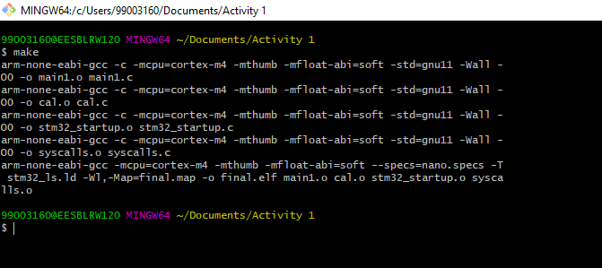

Figure 1: Object File Creation

# Activity 2: Mini Project

**Motion Triggered Night Lamp**

## Link to repository: <https://github.com/Genesis99003160/Embedded-C>

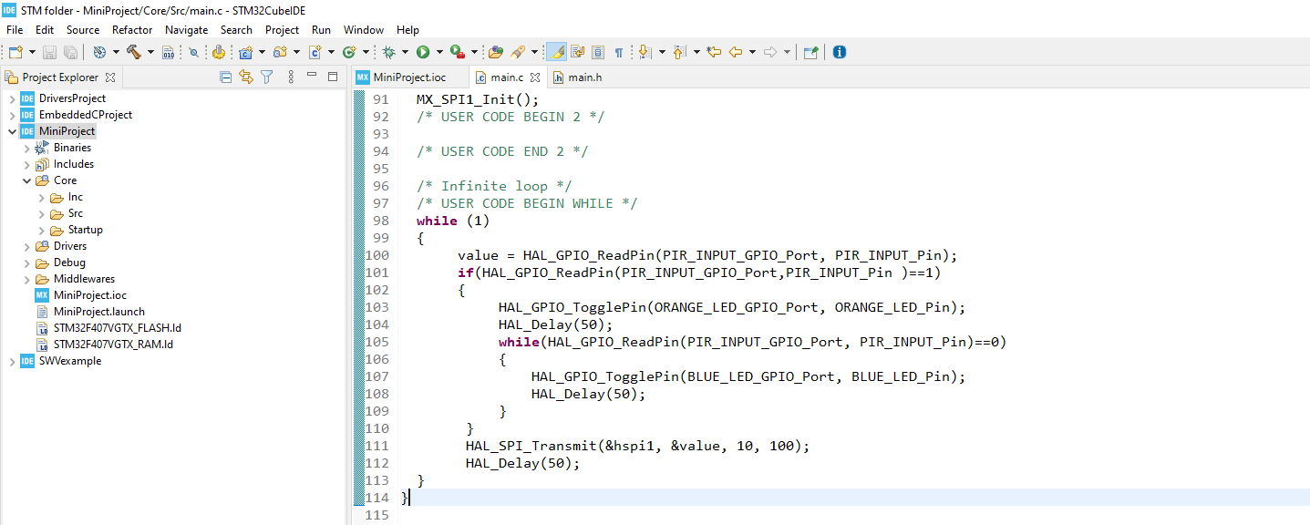

Figure 2: Source code

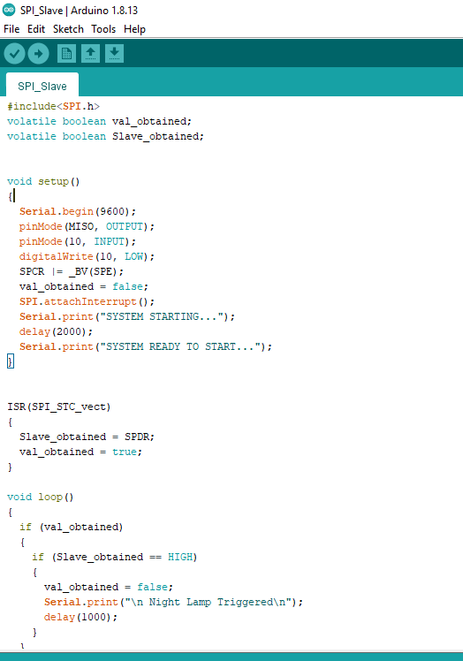

Figure 3: Slave code for SPI Protocol